**HYBRID LANGUAGE TRANSLATOR**

*A Mini Project Report Submitted*

*In partial fulfillment of the requirement for the award of the degree of*

**Bachelor of Technology**

**In**

**Computer Science and Engineering -Artificial Intelligence and Machine Learning**

**by**

**V.SAI CHARAN – 21N31A66J8**

**V.SAI RAM - 21N31A66K2**

**V.JANAYETHRI-21N31A66K1**

Under the Guidance of

**D.Chandra Sekhar Reddy**

**Associate. Professor**

**Department of Computational Intelligence**

**MRCET**



**DEPARTMENT OF COMPUTATIONAL INTELLIGENCE**

**MALLA REDDY COLLEGE OF ENGINEERING AND TECHNOLOGY**

(Affiliated to JNTU, Hyderabad)

**ACCREDITED by AICTE-NBA**

**Maisammaguda, Dhulapally post, Secunderabad-500014.**

**2021-2025**



**DECLARATION**

## I hereby declare that the project entitled “Hybrid Language Translator” submitted to Malla Reddy College of Engineering and Technology, affiliated to Jawaharlal Nehru Technological University Hyderabad (JNTUH) for the award of the degree of Bachelor of Technology in Computer Science and Engineering- Artificial Intelligence and Machine Learning is a result of original research work done by me.

It is further declared that the project report or any part thereof has not been previously submitted to any University or Institute for the award of degree or diploma.

V.SAICHARAN 21N31A66J8

V.SAI RAM - 21N31A66K2

V.JANAYETHRI-21N31A66K1





**CERTIFICATE**

This is to certify that this is the bonafide record of the project titled “HYBRID LANGUAGE TRANSLATOR” submitted by v.saicharan (21N31A66J8), v.sairam (21N31A66K2),v.janayethri (21N31A66K1) of B.Tech in the partial fulfillment of the requirements for the degree of Bachelor of Technology in Computer Science and Engineering- Artificial Intelligence and Machine Learning, Dept. of CI during the year 2023-2024. The results embodied in this project report have not been submitted to any other university or institute for the award of any degree or diploma.

**D.Chandra Sekhar Reddy Dr.D.Sujatha**

Associate. Professor

**INTERNAL GUIDE HEAD OF THE DEPARTMENT**



**EXTERNAL EXAMINER**



**ACKNOWLEDGEMENT**

We feel honored and privileged to place our warm salutation to our college Malla Reddy College of Engineering and technology (UGC-Autonomous), our Director ***Dr. VSK Reddy*** who gave us the opportunity to have experience in engineering and profound technical knowledge.

We are indebted to our Principal ***Dr. S. Srinivasa Rao*** for providing us with facilities to do our project and his constant encouragement and moral support which motivated us to move forward with the project.

We would like to express our gratitude to our Head of the Department ***Dr. D. Sujatha*** for encouraging us in every aspect of our system development and helping us realize our full potential.

We would like to thank our application development guide as well as our internal guide

D.Chandra Sekhar Reddy **(Associate. Professor),** for her structured guidance and never-ending encouragement. We are extremely grateful for valuable suggestions and unflinching co-operation throughout application development work.

We would also like to thank all supporting staff of department of CI and all other departments who have been helpful directly or indirectly in making our application development a success.

We would like to thank our parents and friends who have helped us with their valuable suggestions and support has been very helpful in various phases of the completion of the application development.

By

V.SAICHARAN 21N31A66J8

V.SAI RAM - 21N31A66K2

V.JANAYETHRI-21N31A66K1

**ABSTRACT**



The Hybrid Language Translator is an advanced solution for breaking down language barriers and facilitating effective communication across diverse linguistic landscapes. Leveraging state-of-the-art natural language processing (NLP) algorithms and neural machine translation (NMT) techniques, this tool ensures accurate and contextually relevant translations.At its core, the system excels in understanding the nuances of human language, considering context and cultural intricacies. Unlike traditional rule-based approaches, the neural machine translation employed by this system learns from extensive datasets, continuously adapting and improving its translation capabilities.

The training process involves exposure to diverse linguistic datasets, enabling the model to proficiently handle various language pairs. The emphasis on inclusivity is evident in the user-friendly interface, accessible across web browsers, mobile devices, and desktop applications.Real-time translation capabilities empower users to engage in fluid conversations without the need for intermediary language skills. Whether in business, academia, or casual interactions, the language translator aims to make communication natural and barrier-free.Continuous improvement is a key aspect of the system, with machine learning algorithms analyzing user interactions and feedback for iterative updates.

This ensures ongoing enhancements in translation accuracy and overall performance.Beyond linguistic accuracy, the language translator embraces cultural sensitivity, preserving the cultural nuances embedded in language. This approach contributes to building bridges between communities and fostering a more interconnected global society.In essence, the Language Translator stands as a transformative force in artificial intelligence, making communication seamless and meaningful across languages. As it continues to evolve, this tool remains dedicated to overcoming linguistic challenges and promoting understanding in our interconnected world.



**TABLE OF CONTENTS**

**S.No. Topic Page No.**

CHAPTER 1: INTRODUCTION ----------------------------------------------------------- 1-4

1.1: Purpose----------------------------------------------------------------------- 1

1.2: Background of project-----------------------------------------------------1

1.3: Scope of project------------------------------------------------------------2

1.4: Project features------------------------------------------------------------3-4

CHAPTER 2: SYSTEM REQUIREMENTS---------------------------------------------5-9

2.1 H/W Requirements----------------------------------------------------------5

2.2 S/W Requirements ---------------------------------------------------------5

2.3 Functional requirements--------------------------------------------------5-6

2.4 Existing system--------------------------------------------------------------7

2.4.1 Drawbacks of Existing systems --------------------------------8

2.5 Proposed system-----------------------------------------------------------8-9

CHAPTER 3: TECHNOLOGIES USED------------------------------------------------- 10

CHAPTER 4: SYSTEM DESIGN ------------------------------------------------------11-15

4.1: System architecture-----------------------------------------------------11

4.2 UML Diagrams---------------------------------------------------------11-12

4.2.1 Use case diagram---------------------------------------------12

4.2.2 Dataflow Diagram---------------------------------------------13

4.2.3 Sequence Diagram---------------------------------------------14

4.2.4 Activity Diagram----------------------------------------------15

CHAPTER 5: IMPLEMENTATION ------------------------------------------------- 16-25

5.1 Source Code--------------------------------------------------------------16-21

5.2 Output Screens----------------------------------------------------------21-25

5.3 Testing-------------------------------------------------------------------26

CHAPTER 6: CONCLUSION&FUTURE SCOPE----------------------------------26-28



CHAPTER 7: BIBLIOGRAPHY -----------------------------------------------29



**1. INTRODUCTION**

**1.1 Purpose:**

The Hybrid language translator serves a pivotal role in fostering global communication by dismantling language barriers. Leveraging advanced natural language processing and neural machine translation, it excels in providing accurate and contextually rich translations. Its user-friendly interface, accessible across diverse platforms, ensures widespread usability, catering to users with varying levels of technological proficiency.

The primary objective is to facilitate real-time communication, enabling individuals and entities to engage in fluid conversations across linguistic divides. Beyond linguistic accuracy, the system embraces continuous improvement through machine learning, refining its translation capabilities based on user feedback and interactions. This adaptability is crucial for handling the evolving nature of languages and ensuring sustained effectiveness.Cultural sensitivity is embedded in the translator's functionality, preserving the nuances of language that reflect cultural diversity.

**1.2 Background of project:**

The Hybrid Language Translator project emerged in response to the growing need for effective communication across linguistic barriers in our increasingly interconnected world. Initiated by a team of experts in natural language processing (NLP) and machine translation, the project aimed to address the limitations of traditional language translation methods.The background research identified challenges such as nuanced language understanding, context preservation, and cultural sensitivity. Leveraging advancements in neural machine translation (NMT), the team sought to create a solution that goes beyond literal translations, capturing the subtleties of human communication.The project's foundations were laid upon extensive linguistic datasets, encompassing diverse languages and communication styles.

This comprehensive training aimed to equip the language translator with the ability to proficiently handle various language pairs, ensuring its utility on a global scale.User feedback and interactions played a crucial role in the iterative development process. Continuous refinement through machine learning algorithms allowed the translator to adapt and improve over time, making it a dynamic tool capable of addressing evolving language dynamics.Cultural inclusivity was a key consideration in the project's inception, recognizing the importance of preserving cultural nuances within language translations. The goal was not just linguistic accuracy but also fostering understanding and respect between different cultures. As a result, the Language Translator project stands as a testament to the commitment to overcoming linguistic challenges, promoting global connectivity, and creating a tool that contributes to a more interconnected and harmonious global society.

**1.3 Scope of project:**

The Hybrid language translator project aims to create a robust system for seamless translation between different languages. Its scope encompasses the development of a user-friendly interface facilitating text or speech input, utilizing natural language processing and machine learning algorithms for accurate translations.

The project involves comprehensive language support, addressing linguistic nuances, and ensuring a smooth user experience. Scalability is a key consideration, allowing the system to handle increasing volumes of translation requests efficiently.Additional features like real-time translation and compatibility across multiple platforms enhance the project's functionality.

The scope extends to continuous improvement through updates, addressing evolving language patterns, and incorporating user feedback for enhanced performance and usability. Overall, the project aspires to bridge linguistic gaps, promoting effective communication in diverse global contexts..

**1.4 Project Features­­­:**

The system features are as follows:

1. *Multilingual Support:* Enable translation between a wide range of languages, accommodating global users.

2. *User-Friendly Interface:* Design an intuitive interface for seamless input of text or speech, ensuring accessibility and ease of use.

3. *Accurate Translation Algorithms:* Implement advanced natural language processing and machine learning models for precise translations, considering contextual nuances.

4. *Real-Time Translation:* Integrate real-time translation capabilities for immediate communication, catering to dynamic interactions.

5. *Scalability:* Build a scalable system capable of handling varying translation volumes to accommodate increasing user demands.

6. *Offline Mode:* Provide the option for offline translation to ensure accessibility in areas with limited internet connectivity.

7. *Cross-Platform Compatibility:* Support translation across various platforms, including web, mobile, and desktop applications.

8. *Text-to-Speech and Speech-to-Text:* Include features for converting text to speech and vice versa, enhancing versatility in communication.

9. *Language Detection:* Implement automatic language detection to identify input languages accurately.

10. *Feedback Mechanism:* Integrate user feedback mechanisms for continuous improvement, addressing translation accuracy and user experience.

11. *Security Measures:* Prioritize data privacy and implement security measures to safeguard sensitive information during translation processes.

12. *Customization Options:* Allow users to customize translation preferences, including formal or informal language styles.

13. *Integration with APIs:* Facilitate integration with other applications through APIs, promoting interoperability.

14. *Learning and Adaptation:* Incorporate mechanisms for the system to learn and adapt to evolving language trends and user preferences over time.

15. *Error Handling:* Implement robust error-handling mechanisms to gracefully manage translation errors and provide clear feedback to users.

These features collectively contribute to a comprehensive language translator project that meets the diverse needs of users across different contexts.

**2.SYSTEM REQUIREMENTS**

**2.1 Hardware Requirements:**

Operating System

Processor

Memory (RAM)

Input Devices

Display

Language Support

**2.2 Software requirements:**

Operating system

Machine translation software

Translation Management System (TMS)

Version Control System (optional)

Development tools(if required)

**2.3 Functional requirements:**

*Language Support:*

- The translator should support a wide range of languages to cater to diverse user needs.

*Translation Accuracy:*

- Ensure high translation accuracy to provide reliable and contextually correct translations.

*User Interface:*

- Intuitive user interface design for easy navigation and accessibility.

*Input Options:*

- Support for various input methods, such as text, voice, and image recognition, to enhance user convenience.

*Output Formats:*

- Provide translations in multiple formats, including text, audio, and visual outputs.

*Context Awareness:*

- Understand and retain context during translations for more accurate and meaningful results.

*Customization:*

- Allow users to customize language preferences, dialects, and translation styles.

*Speed and Performance:*

- Ensure fast and responsive translations to enhance user experience.

*Multimodal Support:*

- Extend support for translating content across various modalities, including text-to-speech and speech-to-text.

*Documentation and Support:*

- Provide comprehensive documentation and user support to assist users in understanding and using the translator effectively.

**2.4 Existing System:**

As of my last knowledge update in January 2022, various language translation systems exist, each with its unique features and capabilities. Some notable examples include:

1. *Google Translate:* A widely-used online translation service by Google, supporting a vast number of languages. It provides both text and speech translation with the option for real-time translation through the mobile app's camera.

2. *Microsoft Translator:* Offers text and speech translation across multiple languages. It supports various platforms, including web, mobile, and desktop applications.

3. *DeepL Translator:* Known for its neural network-based approach, DeepL Translator focuses on providing high-quality translations for multiple languages.

4. *IBM Watson Language Translator:* Part of IBM's Watson services, it utilizes machine learning techniques for language translation and supports a range of languages.

5. *Yandex.Translate:* Yandex's translation service, covering a broad array of languages. It incorporates machine learning for context-aware translations.

6. *Systran:* Offers translation services for businesses and individuals, providing solutions for various industries, including legal, medical, and technical fields.

7. *SDL Language Cloud:* Provides translation and localization services, catering to businesses with a focus on content management and global communication.

These systems typically employ a combination of statistical machine translation, neural machine translation, and other language processing techniques. Keep in mind that the landscape of language translation technology evolves, and new systems may have emerged or existing ones may have undergone significant updates since my last update in January 2022.

**2.4.1 Drawbacks of existing system:**

While Hybrid language translation systems have made significant advancements, they still come with certain drawbacks:

Accuracy Challenges

Contextual Understanding

Language Pair Disparities

Speech to text challenges

Cost considerations

Dependency on Connectivity

Handling Rare Languages

**2.5 Proposed System:**

A proposed system for a new hybrid language translator could address some of the drawbacks of existing systems by combining the strengths of different approaches. Here are key features of such a system:

*Hybrid Translation Models:* Integrate both statistical machine translation (SMT) and neural machine translation (NMT) models. This hybrid approach can leverage the strengths of each method, providing more accurate translations across various language pairs and contexts.

*Context-Aware Translation:* Implement advanced context-aware algorithms to enhance the system's ability to understand and interpret the meaning behind phrases, considering the broader context of the conversation.

*User Personalization:* Allow users to customize translation preferences, considering individual language nuances and communication styles. This could include an adaptive learning system that refines translations based on user feedback.

*Real-Time Learning:* Enable the system to learn and adapt in real-time from user interactions, continually improving translation accuracy and addressing emerging language trends.

*Offline Mode Enhancement:* Enhance offline capabilities, allowing users to access translations even without a reliable internet connection, improving accessibility in various scenarios.

*Multimodal Translation:* Extend translation beyond text to include multimodal capabilities, incorporating features like image-to-text translation and vice versa, providing a more comprehensive communication experience.

*Domain-Specific Models:* Develop specialized translation models for different domains (e.g., medical, legal, technical), ensuring accurate and contextually relevant translations within specific industries.

*Intuitive User Interface:* Design a user-friendly interface with features like real-time collaboration, suggesting alternative translations.

*Global Language Inclusion:* Strive for inclusivity by expanding language support, especially for less common or endangered languages, promoting a more diverse and accessible translation service.

This proposed hybrid language translator aims to offer a more versatile, accurate, and user-centric solution, combining the strengths of different translation approaches while addressing specific user needs and technological challenges.

3: TECHNOLOGIES USED

The provided code is a Python script that uses the Tkinter library for creating a graphical user interface (GUI) application. The application appears to be a language translator that can convert text input to another language and also has features for speech input and output.Here are some of the technologies used in this script:

1. *Tkinter:* It's a standard GUI (Graphical User Interface) library for Python.

2. *os:* The os module provides a way of interacting with the operating system, and in this case, it's used for removing the temporary MP3 file.

3. *tkinter.messagebox:* This module is used for displaying various types of message boxes.

4. *speech_recognition:* This library is used for recognizing speech from audio sources.

5. *threading:* The threading module is used to create and manage threads, which can run in the background while the main program continues to execute.

6. *deep_translator:* It's a library for translating text using various translation services. In this script, Google Translator is used.

7. *gtts (gTTS):* Stands for Google Text-to-Speech. It's used to convert text into speech.

8. *pydub:* A library for processing audio files.

9. *AudioSegment:* Represents an audio file and is used for playing the generated MP3 file.

10. *OptionMenu:* Part of Tkinter, it provides a dropdown menu for selecting options.

11. *Canvas:* Used for drawing shapes and backgrounds in the GUI.

12.*Google Translator API:*

The application seems to have functionality for inputting text, translating it to another language, and playing back the translated text using speech synthesis. Additionally, it supports voice input using a microphone.If you have any specific questions about the code or if you need further clarification on any part, feel free to ask!

**4. SYSTEM DESIGN**

**4.1 System Architecture**

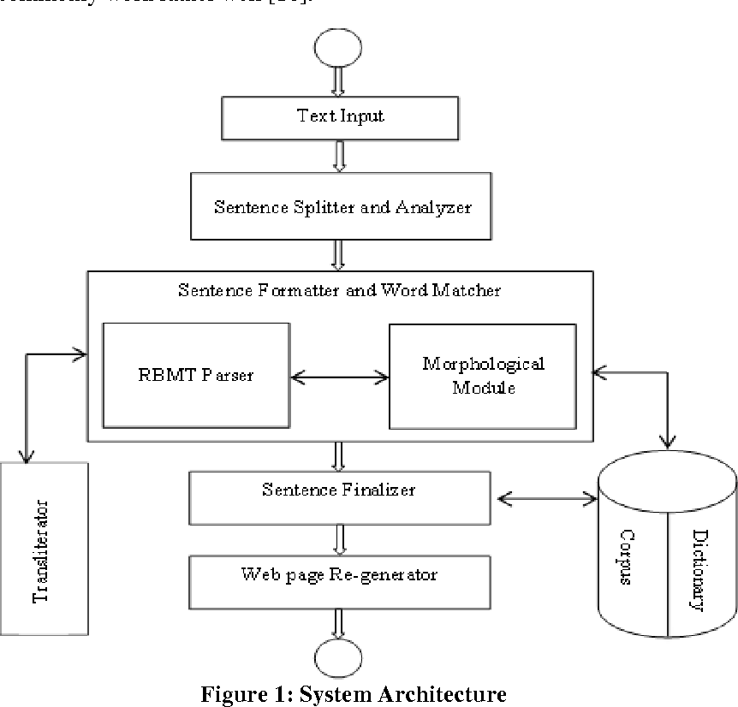

**4.2 UML Diagrams**

Unified modeling is a standard language for specifying, visualizing, constructing, and documenting the system and its components. It is a graphical language which provides a vocabulary and set of semantics and rules. The UML focuses on the conceptual and physical representation of the system. It captures the decisions and understandings about systems that must be constructed. It is used to understand, design, configure and control information about systems.

Depending on the development culture, some of these artifacts are treated more formally than others.

Such artifacts are not only the deliverables of a project; they are also critical in controlling, measuring, and communicating about a system during its development and after its deployment.

The UML addresses the documentation of a system's architecture and all its details. The UML also provides a language for expressing requirements and for tests. Finally, the UML provides a language for modeling the activities of project planning and release management

**4.2.1 Use case diagram**

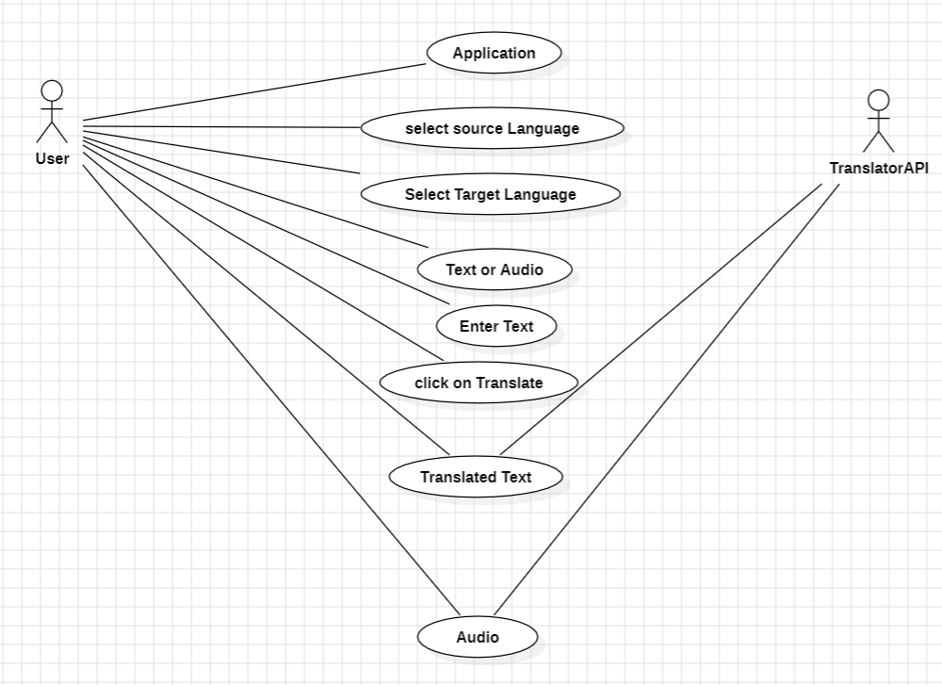

**4.2.2 Dataflow Diagram**

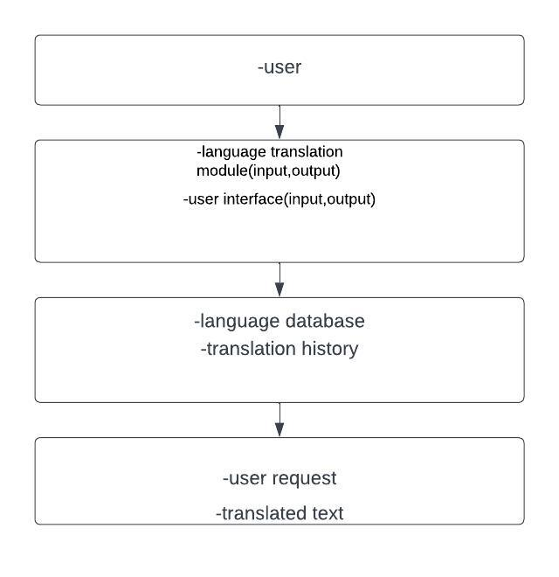

#### **4.2.3 Sequence Diagram**

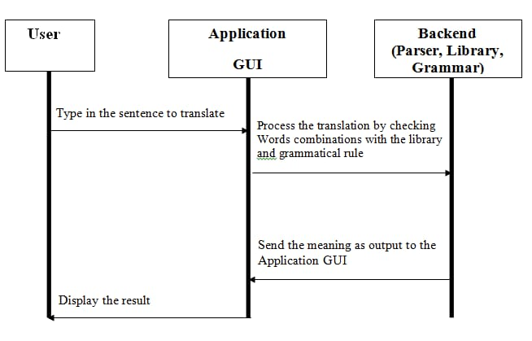

Start speaking.

#### **4.2.4 Activity Diagram**

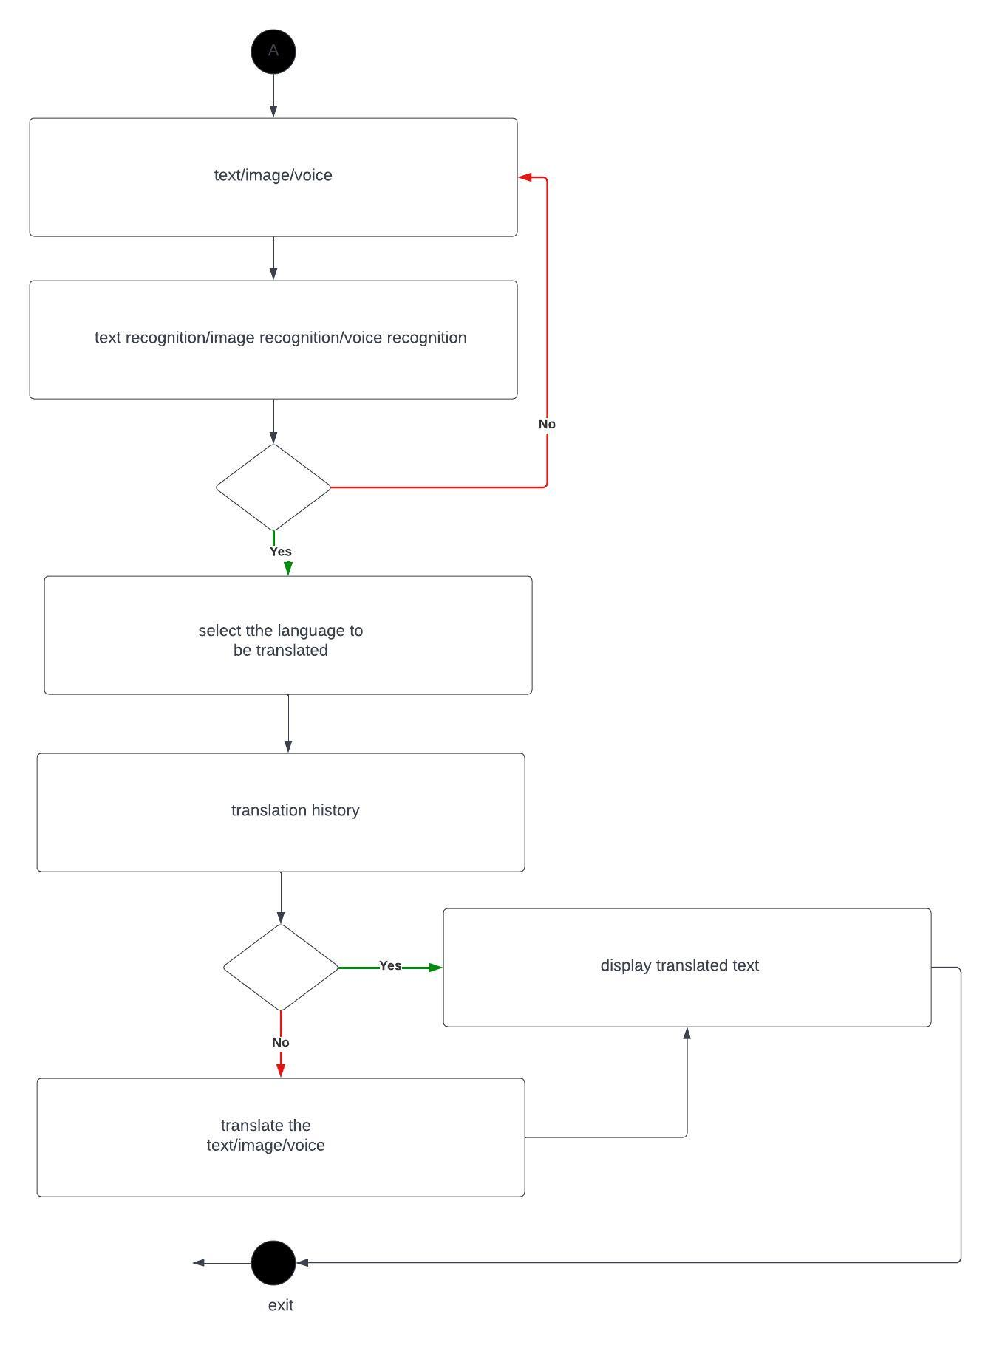

**5.IMPLEMENTATION**

**5.1: Code**

from tkinter import *

import os

import tkinter.messagebox as tkMessageBox

import speech_recognition as sr

import threading as td

from deep_translator import GoogleTranslator

from gtts import gTTS

from pydub import AudioSegment

from pydub.playback import play

AudioSegment.converter = r"C:\ffmpeg\ffmpeg.exe"

r = sr.Recognizer()

main = Tk()

main.title("Hybrid Language Translator")

main.geometry("940x570")

main.config(bg="#C7F8FF")

main.resizable(0, 0)

lt = [

"Afrikaans", "Albanian", "Amharic", "Arabic", "Armenian", "Azerbaijani",

"Bengali", "Bosnian", "Bulgarian", "Catalan", "Chinese (Simplified)", "Chinese (Traditional)",

"Croatian", "Czech", "Danish", "Dutch", "English", "Esperanto", "Estonian", "Filipino",

"Finnish", "French", "Georgian", "German", "Greek", "Gujarati", "Haitian Creole",

"Hausa", "Hebrew", "Hindi", "Hmong", "Hungarian", "Icelandic", "Igbo", "Indonesian",

"Irish", "Italian", "Japanese", "Javanese", "Kannada", "Kazakh", "Khmer", "Korean",

"Lao", "Latin", "Latvian", "Lithuanian", "Luxembourgish", "Macedonian", "Malay",

"Maltese", "Maori", "Marathi", "Mongolian", "Nepali", "Norwegian", "Persian", "Polish",

"Portuguese", "Punjabi", "Romanian", "Russian", "Serbian", "Sesotho", "Sinhala",

"Slovak", "Slovenian", "Somali", "Spanish", "Sundanese", "Swahili", "Swedish",

"Tamil", "Telugu", "Thai", "Turkish", "Ukrainian", "Urdu", "Uzbek", "Vietnamese",

"Welsh", "Xhosa", "Yiddish", "Yoruba", "Zulu"

]

v1 = StringVar(main)

v1.set(lt[0])

v2 = StringVar(main)

v2.set(lt[1])

Label(main, text="TranslateLanguageviaVoice/TextCommands", font=("", 18, "bold"), bg="#C7F8FF", fg="black").place(x=240, y=20)

flag = False

can = Canvas(main, width=400, height=450, bg="#17C3B2", relief="solid", bd=1, highlightthickness=0)

can.place(x=30, y=80)

Label(main, text="Input Box :", font=("", 12, "bold"), bg="#17C3B2", fg="black").place(x=44, y=70)

can = Canvas(main, width=400, height=450, bg="#17C3B2", relief="solid", bd=1, highlightthickness=0)

can.place(x=490, y=80)

Label(main, text="Output Box :", font=("", 12, "bold"), bg="#17C3B2", fg="black").place(x=780, y=60)

txtbx = Text(main, width=40, height=7, font=("", 12, "bold"), relief="solid", bd=0, highlightthickness=0)

txtbx.place(x=50, y=100)

txtbx2 = Text(main, width=40, height=7, font=("", 12, "bold"), relief="solid", bd=0, highlightthickness=0)

txtbx2.place(x=510, y=100)

def speak():

global txtbx2

tx = txtbx2.get("1.0", END)

code = [

"af", "sq", "am", "ar", "hy", "az", "bn", "bs", "bg", "ca", "zh-CN", "zh-TW", "hr", "cs", "da", "nl",

"en", "eo", "et", "tl", "fi", "fr", "ka", "de", "el", "gu", "ht", "ha", "iw", "hi", "hu", "is", "ig",

"id", "ga", "it", "ja", "jw", "kn", "kk", "km", "ko", "lo", "la", "lv", "lt", "lb", "mk", "ms", "mt",

"mi", "mr", "mn", "ne", "no", "fa", "pl", "pt", "pa", "ro", "ru", "sr", "st", "si", "sk", "sl", "so",

"es", "su", "sw", "sv", "ta", "te", "th", "tr", "uk", "ur", "uz", "vi", "cy", "xh", "yi", "yo", "zu"

]

language = code[lt.index(v2.get())]

myobj = gTTS(text=tx, lang=language, slow=False)

try:

os.remove("temp.mp3")

except:

pass

myobj.save("temp.mp3")

song = AudioSegment.from_mp3("temp.mp3")

play(song)

def translate():

global txtbx, txtbx2

txtbx2.delete("1.0", "end-1c")

tx = txtbx.get("1.0", END)

code = [

"af", "sq", "am", "ar", "hy", "az", "bn", "bs", "bg", "ca", "zh-CN", "zh-TW", "hr", "cs", "da", "nl",

"en", "eo", "et", "tl", "fi", "fr", "ka", "de", "el", "gu", "ht", "ha", "iw", "hi", "hu", "is", "ig",

"id", "ga", "it", "ja", "jw", "kn", "kk", "km", "ko", "lo", "la", "lv", "lt", "lb", "mk", "ms", "mt",

"mi", "mr", "mn", "ne", "no", "fa", "pl", "pt", "pa", "ro", "ru", "sr", "st", "si", "sk", "sl", "so",

"es", "su", "sw", "sv", "ta", "te", "th", "tr", "uk", "ur", "uz", "vi", "cy", "xh", "yi", "yo", "zu"

]

lang = code[lt.index(v2.get())]

translated = GoogleTranslator(source='auto', target=lang).translate(tx)

txtbx2.insert("end-1c",translated)

def detect():

global flag,txtbx

while(1):

if flag==True:

print("breaked")

break

try:

with sr.Microphone() as source2:

r.adjust_for_ambient_noise(source2, duration=0.2)

audio2 = r.listen(source2)

MyText = r.recognize_google(audio2)

MyText = MyText.lower()

txtbx.insert("end-1c", MyText)

except sr.RequestError as e:

tkMessageBox.showinfo("warning","Could not request results; {0}".format(e))

break

except sr.UnknownValueError:

tkMessageBox.showinfo("warning","unknown error occured")

break

def start():

global flag,b1

flag=False

b1["text"]= "Stop Speaking"

b1["command"] = stop

td.Thread(target=detect).start()

def stop():

global flag,b1

b1["text"] = "Give Voice Input"

b1["command"] = start

flag=True

b1=Button(main,text="GiveVoiceInput",font=("",12,"bold"),width=35,height=1,bg="#FEF9EF",fg="black",command=start,relief="solid",bd=4,highlightthickness=0)

b1.place(x=50,y=250)

Button(main,text="SpeakText",font=("",12,"bold"),width=35,height=1,bg="#FEF9EF",fg="black",command=speak,relief="solid",bd=4,highlightthickness=0).place(x=510,y=250)

Button(main,text="Translate",font=("",15,"bold"),width=71,height=3,bg="#FEF9EF",fg="black",command=translate,relief="solid",bd=3,highlightthickness=0).place(x=30,y=446)

Label(main,text="SelectLanguage:",font=("",12,"bold"),bg="#17C3B2",fg="black").place(x=50,y=300)

Label(main,text="SelectLanguage:",font=("",12,"bold"),bg="#17C3B2",fg="black").place(x=510,y=300)

o1 = OptionMenu(main,v1,*lt)

o1.config(font=("",12,"bold"),width=36,bg="#FEF9EF",fg="black",relief="solid",bd=1,highlightthickness=0)

o1.place(x=50,y=340)

o2 = OptionMenu(main,v2,*lt)

o2.config(font=("",12,"bold"),width=36,bg="#FEF9EF",fg="black",relief="solid",bd=1,highlightthickness=0)

o2.place(x=510,y=340)

main.mainloop()

**5.2: Output Screens:**

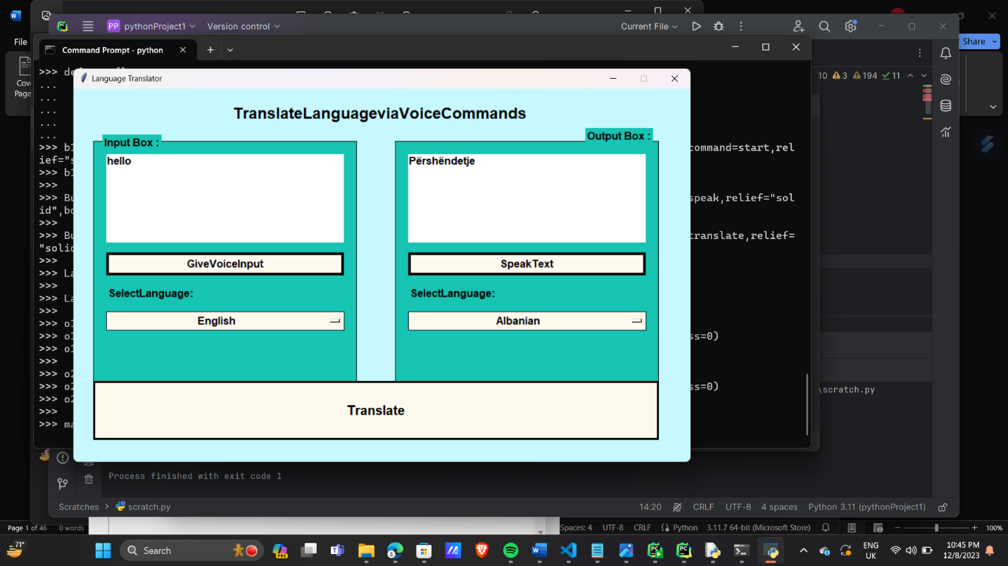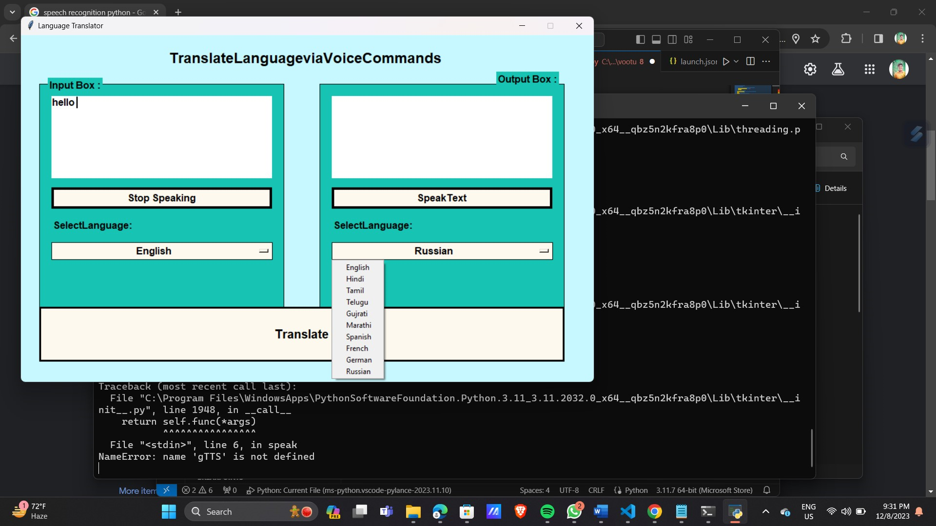

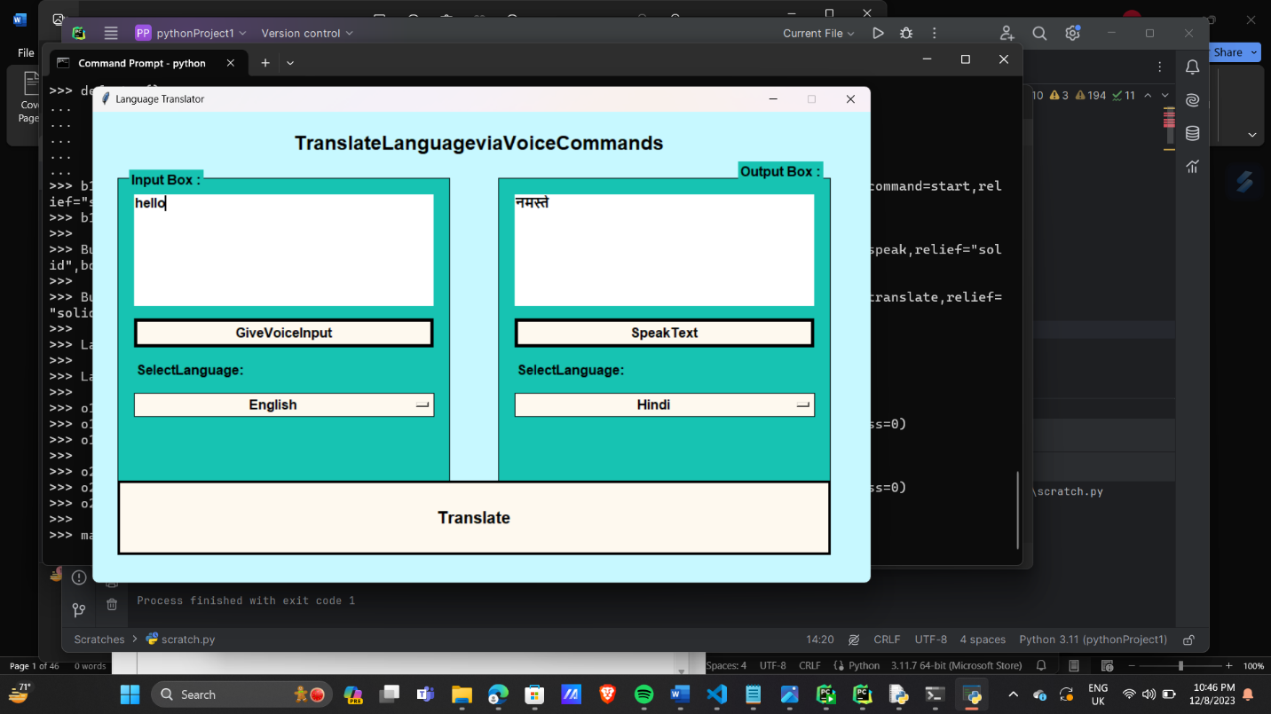

j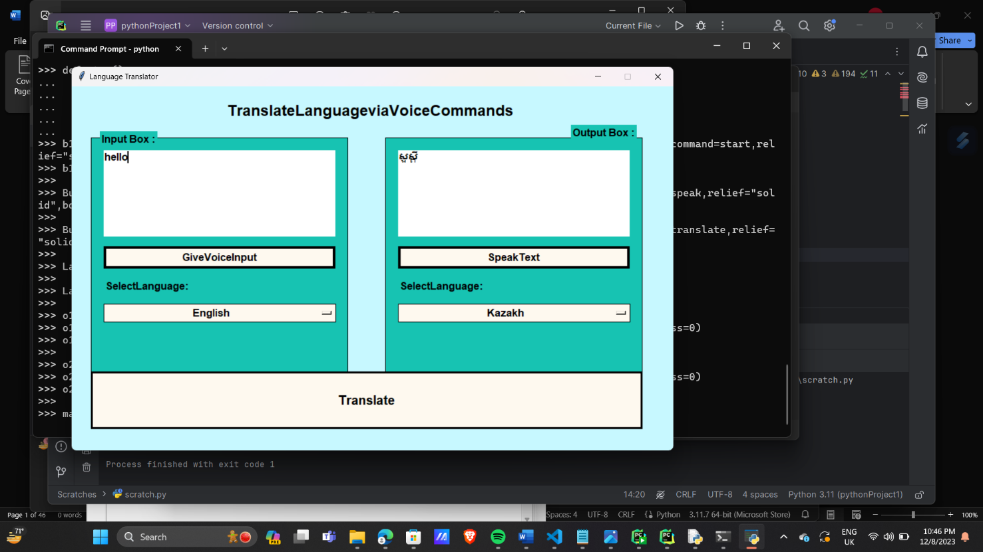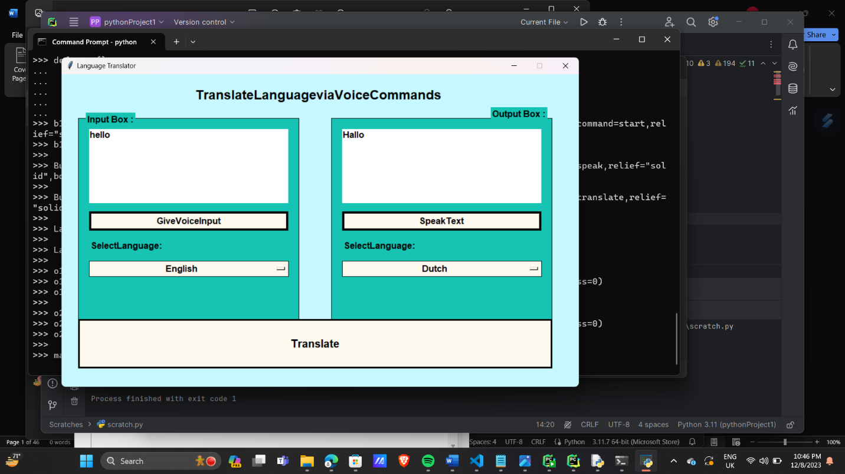

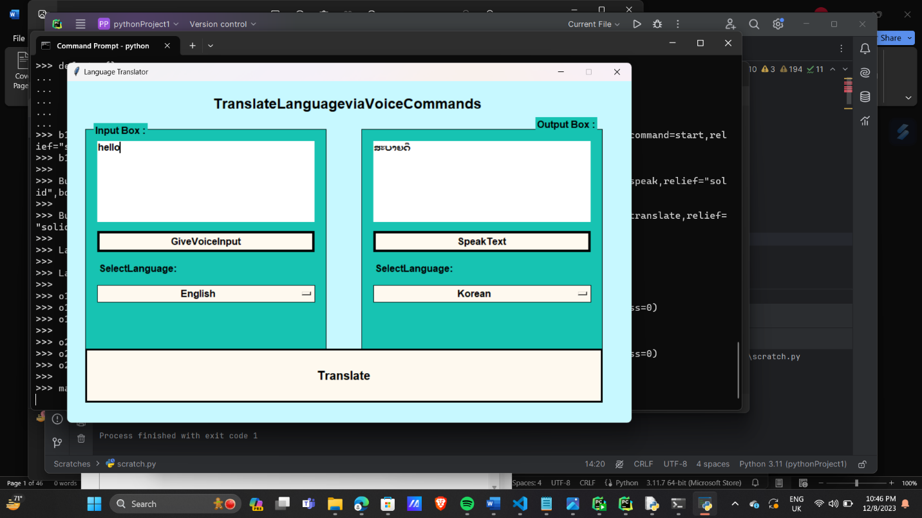

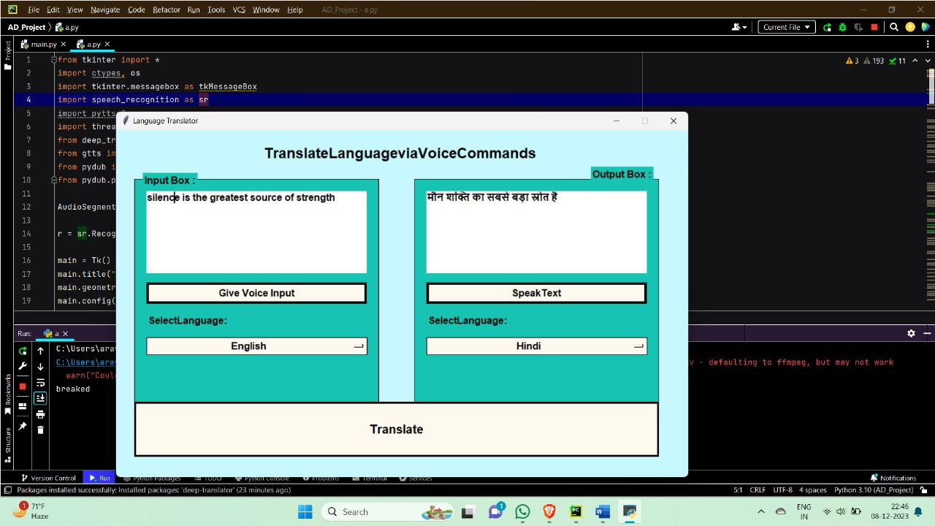

**5.3: Testing**

When testing a hybrid language translator application, you would typically cover various aspects such as functionality, usability, performance, and reliability. Here's a basic outline for a testing module:

Functionality Testing

Usability Testing

Performance Testing

Reliability Testing

Localization Testing

Accessibility Testing

Documentation

User Acceptance Testing (UAT)

Remember to adapt this testing module based on the specific requirements and features of your hybrid language translator application. Each testing phase should be thorough, and issues should be documented and addressed before releasing the software.

**6. CONCLUSION & FUTURE SCOPE**

Conclusion:

The hybrid language translator application demonstrates a powerful combination of text and speech translation, making it versatile and user-friendly. With the integration of various technologies, including Tkinter for the graphical user interface, Google Translate for text translation, gTTS for text-to-speech conversion, and SpeechRecognition for voice input, the application provides a seamless and interactive translation experience.The key features of the hybrid language translator include the ability to input text, translate it into a wide range of languages, and even receive translations through voice input.

The application's user interface is designed for simplicity, allowing users to easily navigate and interact with the translation functionalitiesThe reliability and performance of the application are crucial factors, ensuring accurate translations and efficient voice input processing. The inclusion of error handling mechanisms and compatibility testing across different platforms contribute to a stable and user-friendly experience.

Future Scope:

*Enhanced Language Support:*

- Continuously expand language support by incorporating additional language codes and refining translation algorithms.

*Improved Voice Recognition:*

- Invest in more advanced voice recognition technologies to enhance the accuracy of voice input and provide a smoother user experience.

*Integration with Advanced Translation APIs:*

- Explore integration with more translation APIs to leverage advanced features and stay updated with the latest translation capabilities.

*User Personalization:*

- Implement user profiles to allow users to save language preferences, customize settings, and personalize their translation experience.

*Offline Translation:*

- Integrate offline translation capabilities, allowing users to translate text and use voice input without requiring a constant internet connection.

*Multimodal Translation:*

- Explore the integration of image-to-text translation for a more comprehensive multimodal translation experience.

*Community Feedback and Collaboration:*

- Establish a feedback loop with users to gather insights, identify areas of improvement, and prioritize features based on user demands.

*Accessibility Features:*

- Implement additional accessibility features, ensuring the application is usable by individuals with diverse needs, including those with disabilities.

*Cross-Platform Compatibility:*

- Develop dedicated versions of the application for various platforms, such as mobile devices, ensuring a seamless experience across different devices.

*Natural Language Processing (NLP) Integration:*

- Investigate the integration of NLP technologies to improve the contextual understanding of input text and deliver more contextually accurate translations.

By considering these future scope areas, the hybrid language translator can evolve into a more sophisticated and feature-rich application, meeting the diverse needs of users seeking efficient and accessible language translation solutions. Regular updates and advancements will ensure the application remains relevant and competitive in the evolving landscape of language translation technology.

**7. BIBLIOGRAPHY**

**REFERENCES:**

[1] Sireesh Haang Limbu, “Direct Speech to Speech Translation Using Machine Learning”, December 2020

[2] S. Venkateswarlu, D. B. K. Kamesh, J. K. R. Sastry and Radhika Rani, “Text to Speech Conversion”, 23 September 2020

[3] Chris Piech, Sami Abu-El-Haija, “Auto-Translation for Localized Instruction”, Sep 2019

[4] Sagar Patil, Mayuri Phonde, Siddharth Prajapati, “Multilingual Speech and Text Recognition and Translation using Image”, April-2020.